Main thread in Java
Java provides built-in support for multithreaded programming. A multi-threaded program contains two or more parts that can run concurrently. Each part of such a program is called a thread, and each thread defines a separate path of execution.
Main Thread
When a Java program starts up, one thread begins running immediately. This is usually called the main thread of our program, because it is the one that is executed when our program begins.
Properties :
- It is the thread from which other “child” threads will be spawned.
- Often, it must be the last thread to finish execution because it performs various shutdown actions
Flow diagram :
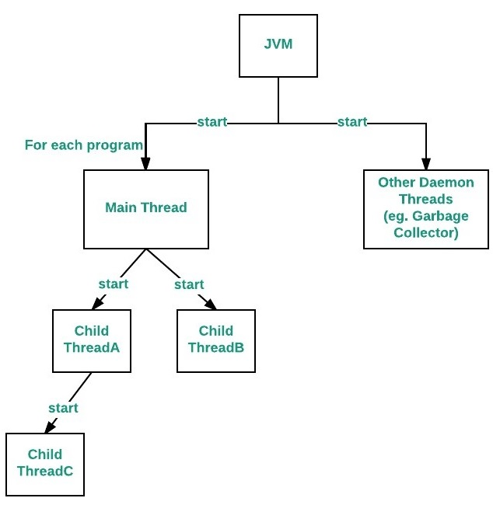

How to control Main thread
The main thread is created automatically when our program is started. To control it we must obtain a reference to it. This can be done by calling the method currentThread( ) which is present in Thread class. This method returns a reference to the thread on which it is called. The default priority of Main thread is 5 and for all remaining user threads priority will be inherited from parent to child.

// Java program to control the Main Thread
public class Test extends Thread
{
public static void main(String[] args)
{
// getting reference to Main thread
Thread t = Thread.currentThread();

// getting name of Main thread
System.out.println("Current thread: " + t.getName());

// changing the name of Main thread
t.setName("Geeks");
System.out.println("After name change: " + t.getName());

// getting priority of Main thread
System.out.println("Main thread priority: "+ t.getPriority());

// setting priority of Main thread to MAX(10)
t.setPriority(MAX_PRIORITY);

System.out.println("Main thread new priority: "+ t.getPriority());

for (int i = 0; i < 5; i++)
{
System.out.println("Main thread");
}

// Main thread creating a child thread
ChildThread ct = new ChildThread();

// getting priority of child thread
// which will be inherited from Main thread
// as it is created by Main thread
System.out.println("Child thread priority: "+ ct.getPriority());

// setting priority of Main thread to MIN(1)
ct.setPriority(MIN_PRIORITY);

System.out.println("Child thread new priority: "+ ct.getPriority());

// starting child thread
ct.start();
}
}

// Child Thread class
class ChildThread extends Thread
{
@Override
public void run()
{
for (int i = 0; i < 5; i++)
{
System.out.println("Child thread");
}
}
}
Output:
Current thread: main
After name change: Geeks
Main thread priority: 5
Main thread new priority: 10
Main thread
Main thread
Main thread
Main thread
Main thread
Child thread priority: 10
Child thread new priority: 1
Child thread
Child thread
Child thread
Child thread
Child thread

Relation between the main() method and main thread in Java
For each program, a Main thread is created by JVM(Java Virtual Machine). The “Main” thread first verifies the existence of the main() method, and then it initializes the class. Note that from JDK 6, main() method is mandatory in a standalone java application.

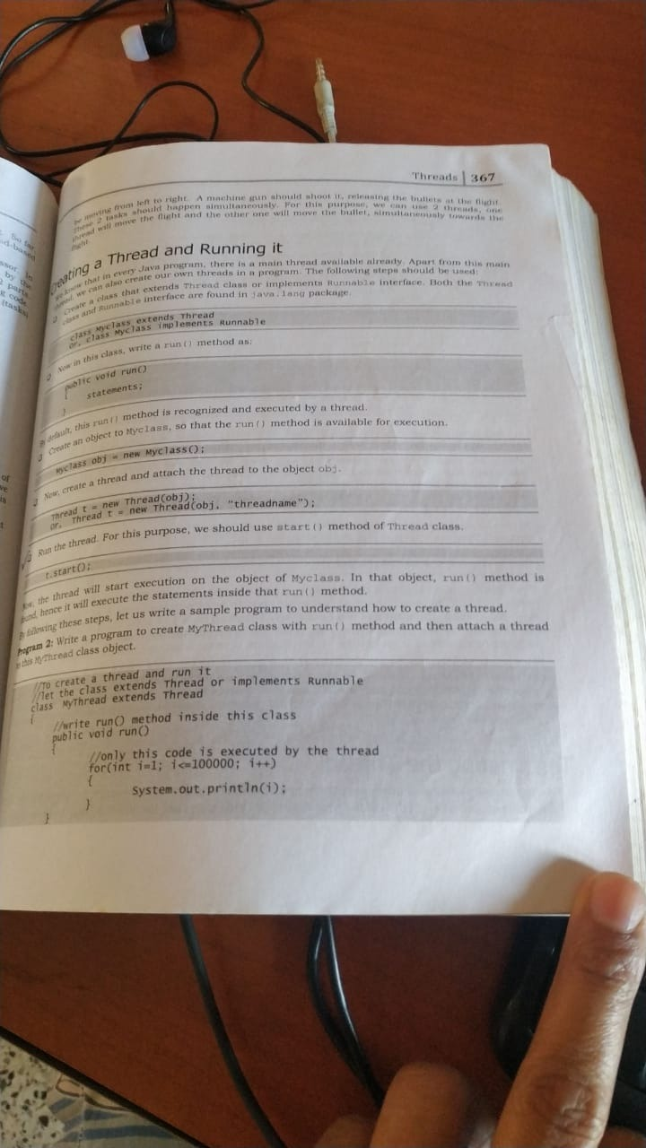

Multithreading in Java
Multithreading is a Java feature that allows concurrent execution of two or more parts of a program for maximum utilization of CPU. Each part of such program is called a thread. So, threads are light-weight processes within a process.
Threads can be created by using two mechanisms :
1. Extending the Thread class
2. Implementing the Runnable Interface
Thread creation by extending the Thread class
We create a class that extends the java.lang.Thread class. This class overrides the run() method available in the Thread class. A thread begins its life inside run() method. We create an object of our new class and call start() method to start the execution of a thread. Start() invokes the run() method on the Thread object.

// Java code for thread creation by extending
// the Thread class
class MultithreadingDemo extends Thread
{
public void run()
{
try
{
// Displaying the thread that is running
System.out.println ("Thread " +
Thread.currentThread().getId() +
" is running");

}
catch (Exception e)
{
// Throwing an exception
System.out.println ("Exception is caught");
}
}
}

// Main Class
public class Multithread
{
public static void main(String[] args)
{
int n = 8; // Number of threads
for (int i=0; i<8; i++)
{
MultithreadingDemo object = new MultithreadingDemo();
object.start();
}
}
}
Output :
Thread 8 is running
Thread 9 is running
Thread 10 is running
Thread 11 is running
Thread 12 is running
Thread 13 is running
Thread 14 is running
Thread 15 is running
Thread creation by implementing the Runnable Interface
We create a new class which implements java.lang.Runnable interface and override run() method. Then we instantiate a Thread object and call start() method on this object.

// Java code for thread creation by implementing
// the Runnable Interface
class MultithreadingDemo implements Runnable
{
public void run()
{
try
{
// Displaying the thread that is running
System.out.println ("Thread " +
Thread.currentThread().getId() +
" is running");

}
catch (Exception e)
{
// Throwing an exception
System.out.println ("Exception is caught");
}
}
}

// Main Class
class Multithread
{
public static void main(String[] args)
{
int n = 8; // Number of threads
for (int i=0; i<n; i++)
{
Thread object = new Thread(new MultithreadingDemo());
object.start();
}
}
}
Output :
Thread 8 is running
Thread 9 is running
Thread 10 is running
Thread 11 is running
Thread 12 is running
Thread 13 is running
Thread 14 is running
Thread 15 is running

Thread Class vs Runnable Interface
1. If we extend the Thread class, our class cannot extend any other class because Java doesn’t support multiple inheritance. But, if we implement the Runnable interface, our class can still extend other base classes.
2. We can achieve basic functionality of a thread by extending Thread class because it provides some inbuilt methods like yield(), interrupt() etc. that are not available in Runnable interface.

Java Thread isAlive() method

How can one thread know when another thread has ended?
Thread provides a means by which you can answer this question. Java multi-threading provides two ways to find that
- isAlive() : The isAlive() method of thread class tests if the thread is alive. A thread is considered alive when the start() method of thread class has been called and the thread is not yet dead. This method returns true if the thread is still running and not finished.

There is a transitional period from when a thread is running to when a thread is not running. After the run() method returns, there is a short period of time before the thread stops. If we want to know if the start method of the thread has been called or if thread has been terminated, we must use isAlive() method. This method is used to find out if a thread has actually been started and has yet not terminated.

General Syntax :

public final boolean isAlive( )
Return Value: returns true if the thread upon
which it is called is still running.
It returns false otherwise.

Example
public class JavaIsAliveExp extends Thread
{
public void run()
{
try
{
Thread.sleep(300);
System.out.println("is run() method isAlive "+Thread.currentThread().isAlive());
}
catch (InterruptedException ie) {
}
}
public static void main(String[] args)
{
JavaIsAliveExp t1 = new JavaIsAliveExp();
System.out.println("before starting thread isAlive: "+t1.isAlive());
t1.start();
System.out.println("after starting thread isAlive: "+t1.isAlive());
}
}
Output:
before starting thread isAlive: false
after starting thread isAlive: true
is run() method isAlive true

join() : When the join() method is called, the current thread will simply wait until the thread it is joining with is no longer alive.
Or we can say the method that you will more commonly use to wait for a thread to finish is called join( ). This method waits until the thread on which it is called terminates. Its name comes from the concept of the calling thread waiting until the specified thread joins it. Additional forms of join( ) allow you to specify a maximum amount of time that you want to wait for the specified thread to terminate.
Syntax :
Example of thread with join()

// Java program to illustrate

public class oneThread extends Thread {
public void run()
{
System.out.println("geeks ");
try {
Thread.sleep(300);
}
catch (InterruptedException ie) {
}
System.out.println("forgeeks ");
}
public static void main(String[] args)
{
oneThread c1 = new oneThread();
oneThread c2 = new oneThread();
c1.start();

try {
c1.join(); // Waiting for c1 to finish
}
catch (InterruptedException ie) {
}

c2.start();
}
}
Output:
geeks
forgeeks
geeks
forgeeks

Lifecycle and States of a Thread in Java
A thread in Java at any point of time exists in any one of the following states. A thread lies only in one of the shown states at any instant:
- New
- Runnable
- Blocked
- Waiting
- Timed Waiting
- Terminated
The diagram shown below represent various states of a thread at any instant of time.
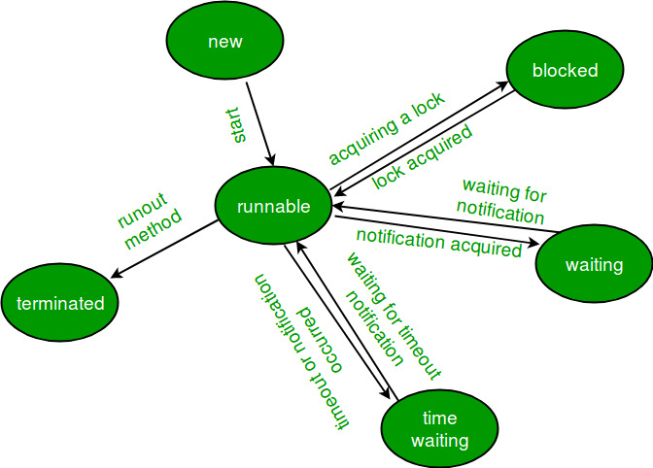

Life Cycle of a thread
- New Thread: When a new thread is created, it is in the new state. The thread has not yet started to run when thread is in this state. When a thread lies in the new state, it’s code is yet to be run and hasn’t started to execute.
- Runnable State: A thread that is ready to run is moved to runnable state. In this state, a thread might actually be running or it might be ready to run at any instant of time. It is the responsibility of the thread scheduler to give the thread, time to run.
A multi-threaded program allocates a fixed amount of time to each individual thread. Each and every thread runs for a short while and then pauses and relinquishes the CPU to another thread, so that other threads can get a chance to run. When this happens, all such threads that are ready to run, waiting for the CPU and the currently running thread lies in runnable state.
- Blocked/Waiting state:When a thread is temporarily inactive, then it’s in one of the following states:
  - Blocked
  - Waiting
For example, when a thread is waiting for I/O to complete, it lies in the blocked state. It’s the responsibility of the thread scheduler to reactivate and schedule a blocked/waiting thread. A thread in this state cannot continue its execution any further until it is moved to runnable state. Any thread in these states does not consume any CPU cycle.
A thread is in the blocked state when it tries to access a protected section of code that is currently locked by some other thread. When the protected section is unlocked, the schedule picks one of the thread which is blocked for that section and moves it to the runnable state. Whereas, a thread is in the waiting state when it waits for another thread on a condition. When this condition is fulfilled, the scheduler is notified and the waiting thread is moved to runnable state.
If a currently running thread is moved to blocked/waiting state, another thread in the runnable state is scheduled by the thread scheduler to run. It is the responsibility of thread scheduler to determine which thread to run.
- Timed Waiting: A thread lies in timed waiting state when it calls a method with a time out parameter. A thread lies in this state until the timeout is completed or until a notification is received. For example, when a thread calls sleep or a conditional wait, it is moved to a timed waiting state.
- Terminated State: A thread terminates because of either of the following reasons:
  - Because it exists normally. This happens when the code of thread has entirely executed by the program.
  - Because there occurred some unusual erroneous event, like segmentation fault or an unhandled exception.
A thread that lies in a terminated state does no longer consumes any cycles of CPU.
// Java program to demonstrate thread states
class thread implements Runnable
{
public void run()
{
// moving thread2 to timed waiting state
try
{
Thread.sleep(1500);
}
catch (InterruptedException e)
{
e.printStackTrace();
}

System.out.println("State of thread1 while it called join() method on thread2 -"+
Test.thread1.getState());
try
{
Thread.sleep(200);
}
catch (InterruptedException e)
{
e.printStackTrace();
//used to handle exception and errors and prints with line no and class name where error /exception occured
}
}
}

public class Test implements Runnable
{
public static Thread thread1;
public static Test obj;

public static void main(String[] args)
{
obj = new Test();
thread1 = new Thread(obj);

// thread1 created and is currently in the NEW state.
System.out.println("State of thread1 after creating it - " + thread1.getState());
thread1.start();

// thread1 moved to Runnable state
System.out.println("State of thread1 after calling .start() method on it - " +
thread1.getState());
}

public void run()
{
thread myThread = new thread();
Thread thread2 = new Thread(myThread);

// thread1 created and is currently in the NEW state.
System.out.println("State of thread2 after creating it - "+ thread2.getState());
thread2.start();

// thread2 moved to Runnable state
System.out.println("State of thread2 after calling .start() method on it - " +
thread2.getState());

// moving thread1 to timed waiting state
try
{
//moving thread1 to timed waiting state
Thread.sleep(200);
}
catch (InterruptedException e)
{
e.printStackTrace();
}
System.out.println("State of thread2 after calling .sleep() method on it - "+
thread2.getState() );

try
{
// waiting for thread2 to die
thread2.join();
}
catch (InterruptedException e)
{
e.printStackTrace();
}
System.out.println("State of thread2 when it has finished it's execution - " +
thread2.getState());
}

}
Output:
State of thread1 after creating it - NEW
State of thread1 after calling .start() method on it - RUNNABLE
State of thread2 after creating it - NEW
State of thread2 after calling .start() method on it - RUNNABLE
State of thread2 after calling .sleep() method on it - TIMED_WAITING
State of thread1 while it called join() method on thread2 -WAITING
State of thread2 when it has finished it's execution - TERMINATED
Explanation: When a new thread is created, the thread is in the NEW state. When .start() method is called on a thread, the thread scheduler moves it to Runnable state. Whenever join() method is called on a thread instance, the current thread executing that statement will wait for this thread to move to Terminated state. So, before the final statement is printed on the console, the program calls join() on thread2 making the thread1 wait while thread2 completes its execution and is moved to Terminated state. thread1 goes to Waiting state because it is waiting for thread2 to complete it’s execution as it has called join on thread2.

Priority of a Thread (Thread Priority):
Each thread have a priority. Priorities are represented by a number between 1 and 10. In most cases,
thread schedular schedules the threads according to their priority (known as preemptive scheduling).
But it is not guaranteed because it depends on JVM specification that which scheduling it chooses.

3 constants defined in Thread class:
- public static int MIN_PRIORITY
- public static int NORM_PRIORITY
- public static int MAX_PRIORITY

Default priority of a thread is 5 (NORM_PRIORITY). The value of MIN_PRIORITY is 1 and
the value of MAX_PRIORITY is 10.

Example of priority of a Thread:
class TestMultiPriority1 extends Thread{
public void run(){
System.out.println("running thread name is:"+Thread.currentThread().getName());
System.out.println("running thread priority is:"+Thread.currentThread().getPriority());

}
public static void main(String args[]){
TestMultiPriority1 m1=new TestMultiPriority1();
TestMultiPriority1 m2=new TestMultiPriority1();
m1.setPriority(Thread.MIN_PRIORITY);
m2.setPriority(Thread.MAX_PRIORITY);
m1.start();
m2.start();

}
}

Output:running thread name is:Thread-0
running thread priority is:10
running thread name is:Thread-1
running thread priority is:1

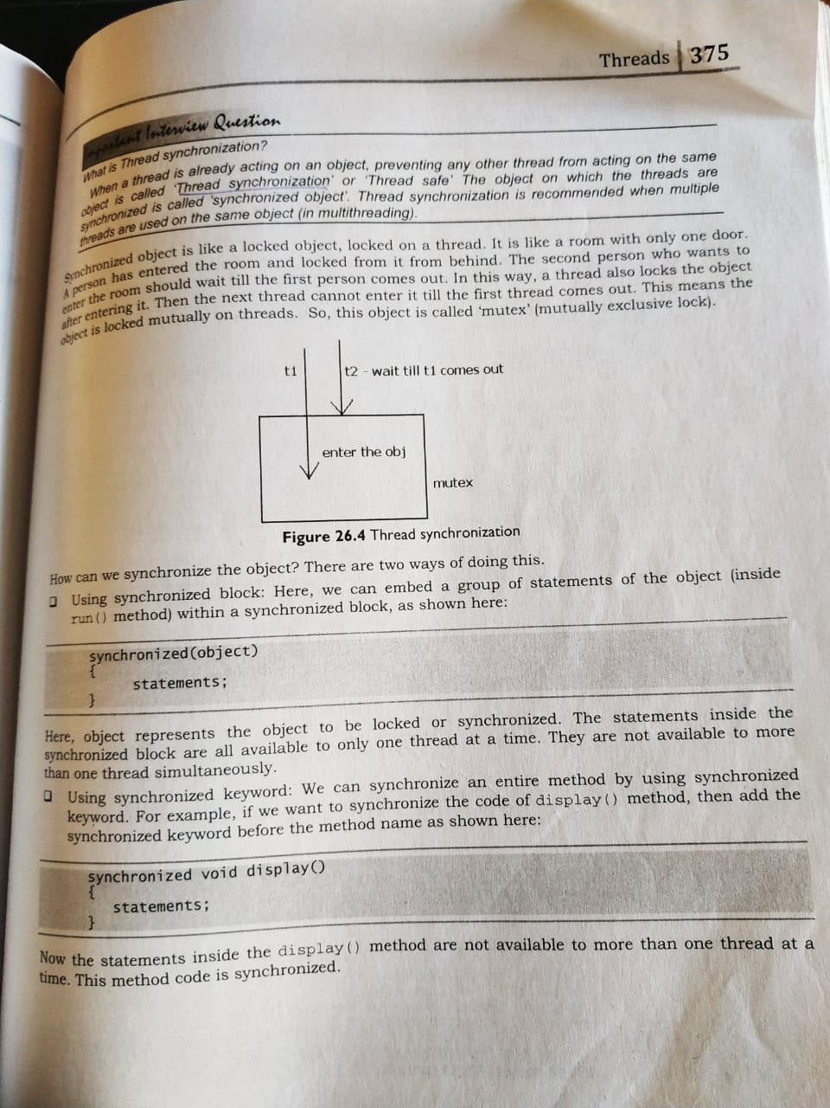

Synchronization in Java
Synchronization in java is the capability to control the access of multiple threads to any shared resource.
Java Synchronization is better option where we want to allow only one thread to access the shared resource.

Why use Synchronization
VLC
MUSIC
VIDEO
TIMER
PROGRESS BAR

T1.start()
T2.start()
T3.start()

T1 ----5 LINE OF CODE (LOCK)
UNLOCK
WAITING
T2 (lock)
UNLOCK
WAITING
T3 (LOCK)
UNLOCK
-------------------------
T2
T3
T1
T3
T2
T1
T2
T1
T3
T1.JOIN ()
T2.JOIN()
T3.JOIN()

The synchronization is mainly used to
- To prevent thread interference.
- To prevent consistency problem.

Types of Synchronization
There are two types of synchronization
- Process Synchronization
- Thread Synchronization
Here, we will discuss only thread synchronization.

Thread Synchronization
There are two types of thread synchronization mutual exclusive and inter-thread communication.
- Mutual Exclusive
  - Synchronized method.
  - Synchronized block.
  - static synchronization.
- Cooperation (Inter-thread communication in java)

Mutual Exclusive
Mutual Exclusive helps keep threads from interfering with one another while sharing data. This can be done by three ways in java:
T2/t3/T4/T5
- by synchronized method
T1
A=A-50
COMMIT
- by synchronized block
- by static synchronization

Concept of Lock in Java
Synchronization is built around an internal entity known as the lock or monitor. Every object has a lock associated with it. By convention, a thread that needs consistent access to an object's fields has to acquire the object's lock before accessing them, and then release the lock when it's done with them.
From Java 5 the package java.util.concurrent.locks contains several lock implementations.

Understanding the problem without Synchronization
In this example, there is no synchronization, so output is inconsistent. Let's see the example:
class Table{
void printTable(int n){//method not synchronized
for(int i=1;i<=5;i++){
System.out.println(n*i);
try{
Thread.sleep(400);
}catch(Exception e){System.out.println(e);}
}

}
}

class MyThread1 extends Thread{
Table t;
MyThread1(Table t){
this.t=t;
}
public void run(){
t.printTable(5);
}

}
class MyThread2 extends Thread{
Table t;
MyThread2(Table t){
this.t=t;
}
public void run(){
t.printTable(100);
}
}

class TestSynchronization1{
public static void main(String args[]){
Table obj = new Table();//only one object
MyThread1 t1=new MyThread1(obj);
MyThread2 t2=new MyThread2(obj);
t1.start();
t2.start();
}
}
Output: 5
100
10
200
15
300
20
400
25
500

Java synchronized method
If you declare any method as synchronized, it is known as synchronized method.
Synchronized method is used to lock an object for any shared resource.
When a thread invokes a synchronized method, it automatically acquires the lock for that object and releases it when the thread completes its task.
- //example of java synchronized method
- class Table{

- synchronized void printTable(int n){//synchronized method
- for(int i=1;i<=5;i++){
- System.out.println(n*i);
- try{
- Thread.sleep(400);
- }catch(Exception e){System.out.println(e);}
- }

- }
- }

- class MyThread1 extends Thread{
- Table t;
- MyThread1(Table t){
- this.t=t;
- }
- public void run(){
- t.printTable(5);
- }

- }
- class MyThread2 extends Thread{
- Table t;
- MyThread2(Table t){
- this.t=t;
- }
- public void run(){
- t.printTable(100);
- }
- }

- public class TestSynchronization2{
- public static void main(String args[]){
- Table obj = new Table();//only one object
- MyThread1 t1=new MyThread1(obj);
- MyThread2 t2=new MyThread2(obj);
- t1.start();
- t2.start();
- }
- }
Output: 5
10
15
20
25
100
200
300
400
500

Synchronized Block in Java
Synchronized block can be used to perform synchronization on any specific resource of the method.
Suppose you have 50 lines of code in your method, but you want to synchronize only 5 lines, you can use synchronized block.
If you put all the codes of the method in the synchronized block, it will work same as the synchronized method.

Points to remember for Synchronized block
- Synchronized block is used to lock an object for any shared resource.
- Scope of synchronized block is smaller than the method.
Syntax to use synchronized block
- synchronized (object reference expression) {
- //code block
- }

Example of synchronized block
Let's see the simple example of synchronized block.
Program of synchronized block
class Table{
void printTable(int n){
synchronized(this){//synchronized block
for(int i=1;i<=5;i++){
System.out.println(n*i);
try{
Thread.sleep(400);
}catch(Exception e){System.out.println(e);}
}
}

}//end of the method
}

class MyThread1 extends Thread{
Table t;
MyThread1(Table t){
this.t=t;
}
public void run(){
t.printTable(5);
}

}
class MyThread2 extends Thread{
Table t;
MyThread2(Table t){
this.t=t;
}
public void run(){
t.printTable(100);
}
}

public class TestSynchronizedBlock1{
public static void main(String args[]){
Table obj = new Table();//only one object
MyThread1 t1=new MyThread1(obj);
MyThread2 t2=new MyThread2(obj);
t1.start();
t2.start();
}
}

Output:5
10
15
20
25
100
200
300
400
500

Synchronized static :

class Table{

synchronized static void printTable(int n){//synchronized method
for(int i=1;i<=5;i++){
System.out.println(n*i);
try{
Thread.sleep(400);
}catch(Exception e){System.out.println(e);}
}

}
}

class MyThread1 extends Thread{
Table t;
MyThread1(Table t){
this.t=t;
}
public void run(){
t.printTable(5);
}

}
class MyThread2 extends Thread{
Table t;
MyThread2(Table t){
this.t=t;
}
public void run(){
t.printTable(100);
}
}

public class TestSynchronization2{
public static void main(String args[]){
Table obj = new Table();//only one object
MyThread1 t1=new MyThread1(obj);
MyThread2 t2=new MyThread2(obj);
t1.start();
t2.start();
}
}
Output: 5
10
15
20
25
100
200
300
400
500

Deadlock in java
Deadlock in java is a part of multithreading. Deadlock can occur in a situation when a thread is waiting for an object lock, that is acquired by another thread and second thread is waiting for an object lock that is acquired by first thread. Since, both threads are waiting for each other to release the lock, the condition is called deadlock.



Example of Deadlock in java

public class TestDeadlockExample1 {
public static void main(String[] args) {
final String resource1 = "ratan jaiswal";
final String resource2 = "vimal jaiswal";
// t1 tries to lock resource1 then resource2
Thread t1 = new Thread() {
public void run() {
synchronized (resource1) {
System.out.println("Thread 1: locked resource 1");

try { Thread.sleep(100);} catch (Exception e) {}

synchronized (resource2) {
System.out.println("Thread 1: locked resource 2");
}
}
}
};

// t2 tries to lock resource2 then resource1
Thread t2 = new Thread() {
public void run() {
synchronized (resource2) {
System.out.println("Thread 2: locked resource 2");

try { Thread.sleep(100);} catch (Exception e) {}

synchronized (resource1) {
System.out.println("Thread 2: locked resource 1");
}
}
}
};

t1.start();
t2.start();
}
}

Output: Thread 1: locked resource 1
Thread 2: locked resource 2

Inter-thread communication in Java
Inter-thread communication or Co-operation is all about allowing synchronized threads to communicate with each other.
Cooperation (Inter-thread communication) is a mechanism in which a thread is paused running in its critical section and another thread is allowed to enter (or lock) in the same critical section to be executed.It is implemented by following methods of Object class:
- wait()
- notify()
- notifyAll()

1) wait() method
Causes current thread to release the lock and wait until either another thread invokes the notify() method or the notifyAll() method for this object, or a specified amount of time has elapsed.
The current thread must own this object's monitor, so it must be called from the synchronized method only otherwise it will throw exception.
Method | Description
public final void wait()throws InterruptedException | waits until object is notified.
public final void wait(long timeout)throws InterruptedException | waits for the specified amount of time.

2) notify() method
Wakes up a single thread that is waiting on this object's monitor. If any threads are waiting on this object, one of them is chosen to be awakened. The choice is arbitrary and occurs at the discretion(Judgment ) of the implementation. Syntax:
public final void notify()

3) notifyAll() method
Wakes up all threads that are waiting on this object's monitor. Syntax:
public final void notifyAll()

Understanding the process of inter-thread communication
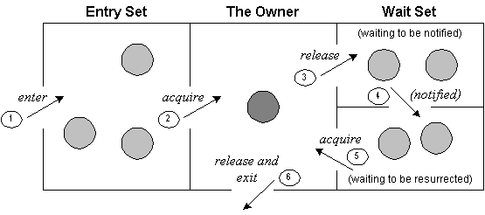
The point to point explanation of the above diagram is as follows:
- Threads enter to acquire lock.
- Lock is acquired by on thread.
- Now thread goes to waiting state if you call wait() method on the object. Otherwise it releases the lock and exits.
- If you call notify() or notifyAll() method, thread moves to the notified state (runnable state).
- Now thread is available to acquire lock.
- After completion of the task, thread releases the lock and exits the monitor state of the object.

Example of inter thread communication in java
Let's see the simple example of inter thread communication.
class Customer{
int amount=10000;

synchronized void withdraw(int amount){
System.out.println("going to withdraw...");

if(this.amount<amount){
System.out.println("Less balance; waiting for deposit...");
try{wait();}catch(Exception e){}
}
this.amount-=amount;
System.out.println("withdraw completed...");
}

synchronized void deposit(int amount){
System.out.println("going to deposit...");
this.amount+=amount;
System.out.println("deposit completed... ");
notify();
}
}

class Test{
public static void main(String args[]){
final Customer c=new Customer();
new Thread(){
public void run(){c.withdraw(15000);}
}.start();
new Thread(){
public void run(){c.deposit(10000);}
}.start();

}}
Output: going to withdraw...
Less balance; waiting for deposit...
going to deposit...
deposit completed...
withdraw completed

wait() | sleep()
wait() method releases the lock | sleep() method doesn't release the lock.
is the method of Object class | is the method of Thread class
is the non-static method | is the static method
should be notified by notify() or notifyAll() methods | after the specified amount of time, sleep is completed

Java Thread suspend() , resume () and stop()method

Core Java provides complete control over multithreaded program. You can develop a multithreaded program which can be suspended, resumed, or stopped completely based on your requirements. There are various static methods which you can use on thread objects to control their behavior. Following table lists down those methods −
Sr.No. | Method & Description
1 | public void suspend()  The suspend() method of thread class puts the thread from running to waiting state. This method is used if you want to stop the thread execution and start it again when a certain event occurs. This method allows a thread to temporarily cease execution.This method puts a thread in the suspended state and can be resumed using resume() method.
2 | public void stop()  This method stops a thread completely.
3 | public void resume()  This method resumes a thread, which was suspended using suspend() method.
4 | public void wait()  Causes the current thread to wait until another thread invokes the notify().
5 | public void notify()  Wakes up a single thread that is waiting on this object's monitor.
Be aware that the latest versions of Java has deprecated the usage of suspend( ), resume( ), and stop( ) methods and so you need to use available alternatives.

Example

class RunnableDemo implements Runnable {
public Thread t;
private String threadName;
boolean suspended = false;

RunnableDemo( String name) {
threadName = name;
System.out.println("Creating " + threadName );
}

public void run() {
System.out.println("Running " + threadName );
try {
for(int i = 10; i > 0; i--) {
System.out.println("Thread: " + threadName + ", " + i);
// Let the thread sleep for a while.
Thread.sleep(300);
synchronized(this) {
while(suspended) {
wait();
}
}
}
} catch (InterruptedException e) {
System.out.println("Thread " + threadName + " interrupted.");
}
System.out.println("Thread " + threadName + " exiting.");
}

public void start () {
System.out.println("Starting " + threadName );
if (t == null) {
t = new Thread (this, threadName);
t.start ();
}
}

void suspend() {
suspended = true;
}

synchronized void resume() {
suspended = false;
notify();
}
}

public class TestThread {

public static void main(String args[]) {

RunnableDemo R1 = new RunnableDemo( "Thread-1");
R1.start();

RunnableDemo R2 = new RunnableDemo( "Thread-2");
R2.start();

try {
Thread.sleep(1000);
R1.suspend();
System.out.println("Suspending First Thread");
Thread.sleep(1000);
R1.resume();
System.out.println("Resuming First Thread");

R2.suspend();
System.out.println("Suspending thread Two");
Thread.sleep(1000);
R2.resume();
System.out.println("Resuming thread Two");
} catch (InterruptedException e) {
System.out.println("Main thread Interrupted");
}try {
System.out.println("Waiting for threads to finish.");
R1.t.join();
R2.t.join();
} catch (InterruptedException e) {
System.out.println("Main thread Interrupted");
}
System.out.println("Main thread exiting.");
}
}
The above program produces the following output −

Output
Creating Thread-1
Starting Thread-1
Creating Thread-2
Starting Thread-2
Running Thread-1
Thread: Thread-1, 10
Running Thread-2
Thread: Thread-2, 10
Thread: Thread-1, 9
Thread: Thread-2, 9
Thread: Thread-1, 8
Thread: Thread-2, 8
Thread: Thread-1, 7
Thread: Thread-2, 7
Suspending First Thread
Thread: Thread-2, 6
Thread: Thread-2, 5
Thread: Thread-2, 4
Resuming First Thread
Suspending thread Two
Thread: Thread-1, 6
Thread: Thread-1, 5
Thread: Thread-1, 4
Thread: Thread-1, 3
Resuming thread Two
Thread: Thread-2, 3
Waiting for threads to finish.
Thread: Thread-1, 2
Thread: Thread-2, 2
Thread: Thread-1, 1
Thread: Thread-2, 1
Thread Thread-1 exiting.
Thread Thread-2 exiting.
Main thread exiting.

